# 



**FEES POLICY 2022/23**

|  |  |
| --- | --- |
| POLICY OWNER: | CFO |
| AUTHOR: | Rachel Jones |
| DATE OF REVIEW: | Nov 2021 |
| DATE OF APPROVAL: |  |
| FOR APPROVAL BY: | Corporation |
| NEXT REVIEW DATE: | Nov 2022 |

**Fees Policy 2022/23**

**Contents**

**1.** **Introduction** 2

**2.** **Policy Objectives** 2

**3.** **Fee Principles** 2

**4.** **Payment Principles** 3

**5.** **Fee Remission** 4

**6.** **Apprenticeships** 5

**7.** **Fee Rates** 5

**8.** **Financial Fee Support** 7

**9.** **Refunds** 7

**Annex 1** 10

**Fees Policy 2022/23**

## **Introduction**

* 1. This policy is approved by the Corporation of BMet and sets out the way in which fees including tuition and other fees are set.
  2. BMet seeks to balance the sustainability of the college versus the affordability of the learning opportunities being made available for all learners.
  3. This policy has been set in compliance with the BMet diversity and inclusion policy.

## **Policy Objectives**

* 1. This policy is intended to:
     1. Outline the approach to fees chargeable to students by BMet.
     2. Be compliant with the guidance as outlined by the Education and Skills Funding Agency (ESFA), West Midlands Combined Authority (WMCA) and Office for Students (OfS) for courses commencing in the academic year 2022/23.
     3. Be clear on how support may be provided by college where fees are a barrier to participation.
     4. Set out how and when fees are payable.

## **Fee Principles**

* 1. The college will take into consideration market analysis regarding demand for provision and the market rate for fees when setting individual course fees, and will set the fee suggested by the funding body, unless there is a specific reason to vary the fees.
  2. This policy acknowledges that BMet adopts this approach in order to generate optimum tuition fee income in line with funding regulations, market conditions and the BMet diversity and inclusion policy.
  3. The following fees and other expenses are chargeable:
     1. A tuition fee.
     2. Awarding organisation fees for registration and examination.
     3. The cost of materials and equipment necessary for the completion of the course.
     4. The college will continue to implement “charge per print” costs for photocopying rather than a flat charge for all students.
     5. The cost of any licenses or disclosure and baring (DBS) checks necessary to achieve the qualification.
     6. The cost of any educational trips or visits that make up part of the course.
     7. The cost of overdue, lost or damaged items borrowed from the Learning Resource Centre.

* + 1. Concessionary policies for all home students.
    2. Fees for external school or college students.
    3. The cost of any additional resit fees after the first two attempts, where the college has delivered good quality teaching and learning and the resits are excessive (excluding English, Maths and Esol qualifications). This would include resits to achieve a higher grade, where the learner has already achieved the qualification/unit.

## **Payment Principles**

* 1. Fees are payable upon enrolment. Depending on the value of the fee and the length of the course the fee can be paid in instalments as prescribed in the college’s instalment agreement with the student at enrolment. A minimum of 20% of the listed tuition fees and all exams and costs listed in the course information are payable at enrolment and the remainder payable throughout the period of study as stipulated.
  2. Instalments will usually cover four payments but can be extended to seven however all fees should be collected prior to the end of the programme. Fees will be collected by bank debit or credit card or by on-line payment (where available).
  3. Interest will not be charged to the student, provided the fees are paid in accordance with the instalment plan. The college reserves the right to charge interest where the instalments are not paid within the agreed instalment plan at the rates set in the Late Payment of Commercial Debt Act 1998.
  4. Sponsored students must provide a valid purchase order from their sponsoring organisation before their enrolment can be completed or in exceptional circumstances, a letter of sponsorship (on headed paper) may be accepted. Should the student’s sponsor fail to pay all or part of the fees due, these will become the responsibility of the individual student.
  5. Where an Advanced Learner Loan or Loan for Higher Education is being used to fund a course it is the responsibility of the student to ensure that this is approved in a timely fashion and the application must be started before the course commences. Students applying for a loan remain liable for the full cost of fees until the loan is fully approved by the Student Loan Company (SLC) and the college, and payments have been authorised by the SLC.
  6. Students can choose to self-finance their courses, instead of taking out the loan with the SLC; the college offers instalments for these students.
  7. It should be noted that SLC payments stop being paid for a student as soon as they withdraw, and the student then becomes responsible for paying the remaining fees owed to the college.
  8. WMCA payments stop being paid for a student as soon as they withdraw. The student then becomes responsible for paying the remaining fees owed to the college.
  9. All fees and debts are collectable by the college and the college will issue reminders to pay. The college will engage debt collecting agencies to collect fees outstanding where all other recovery options have been exhausted.
  10. The college reserves the right to take legal action where all other attempts to collect outstanding debts have failed.
  11. All fees must be settled prior to entry to an examination.
  12. Students with outstanding fees may not receive their certificates and may not enrol on new courses until these are settled.

## **Fee Remission**

* 1. For the purposes of fee remission age is calculated as defined by the ESFA and WMCA as the age on the 31st August in the academic year in which the course starts. However, there are two exceptions to this:
     1. Some level 3 courses are not eligible for fee remission,but are fundable by loans if the learner is 19+ on the first day of learning of the course.
     2. An apprentice’s age is calculated as age on the first day of learning and may impact certain incentive payments to the employer.
  2. Learners aged 16-18, or 19-24 with an Education Health Care Plan (EHCP), who meet the ESFA residency eligibility requirements on ESFA funded courses are subject to full remission for all elements necessary to achieve the course outcome. Where learners have achieved, further fees such as resits may be charged.
  3. Adult learners studying up to level 3 who are eligible have statutory concessions for tuition fees if they can provide valid supporting evidence, as described in the ESFA or WMCA Funding Rules (See summary in Annex 1). This includes appropriate state benefits and also students who have not previously achieved qualifications. This may provide:
     1. Full fee remission.
     2. Co-funding fee remission. This may be further remitted if the student is on a low wage as defined by the ESFA or WMCA, or is able to apply for financial support as defined later in this policy.
     3. Up to four advanced learning loans.
  4. All learners of all ages regardless of remission may still be charged for the following:
     1. “charge per print” costs for photocopying.
     2. Exam costs and subsequent resits where no valid reason is provided for non-attendance at a notified exam.
     3. Optional trips and visits for those who choose to attend.
     4. Costs of equipment, tools, materials or uniforms which will be retained by the learner following completion of the course. These costs will be made clear at enrolment.
     5. Courses outside the main study programme or course where no ESFA/WMCA funding is available.
     6. Exam fees or assessment costs for industry qualifications outside the study programme or course.

## **Apprenticeships**

* 1. Prior to the commencement of an apprenticeship programme BMet will enter into a contract with the employer. This contract will:
     1. Detail any fees and associated payment schedules that have been agreed between both parties.
     2. Detail what happens in the event of the learner failing to complete the apprenticeship in terms of payments and incentives.
     3. Comply with ESFA funding rules for apprenticeships.

## **Fee Rates**

* 1. All adult ESFA/WMCA funded full time courses will be charged at a minimum tuition fee of £2,800 per student per year unless otherwise advertised. Tuition fees may exceed £2,800 for the course dependent upon ESFA/WMCA funding available for the student.
  2. Part time adult courses which are delivered with ESFA/WMCA funding will have a basic fee attached, which is set by the college in accordance with market factors, to stimulate recruitment or to ensure that group sizes are large enough to make running courses viable.
  3. For Advanced Learner Loans the college sets the fees at the maximum loan fee for each course as specified in the Learning Aims system. In some cases the fee charged is slightly more and requires the student to top-up at the point of enrolment. This information is clearly stated in the prospectus, course information and Learning and Funding Information Letter.
  4. For Full Cost Recovery (FCR) courses the college will set the fees taking the following elements into consideration:
     1. Maintenance of fees based on marginal costs and standard group sizes.
     2. Maintenance of minimum group sizes to achieve an appropriate contribution per group.
     3. Rationalisation of the delivery of courses to ensure that the offer remains robust.
     4. Market rates.
  5. Community Learning & Pound Plus Policy
     1. In line with the latest funding guidance the table below illustrates the fees chargeable for community provision:

|  |  |  |  |
| --- | --- | --- | --- |
| Course | Unemployed | Low Waged | Other |
| First community course | No charge | No charge | No charge |
| Subsequent community courses | No charge | No charge | Charged at £4.00/delivery hour |

* + 1. All learners would be required to pay for materials as required.
    2. Learners enrolling on community learning courses are subject to the same eligibility criteria as stated above.
    3. Through partnerships in the community, the major sources of pound plus appear to be:
* accommodation, provided free of charge by community partners;

• support staff from community partners providing additional help in the classroom and in ensuring the availability of general administrative service - this was particularly important where learners had learning difficulties and/or disabilities;

• Recruitment and marketing. In most cases recruitment and marketing was done exclusively by community partners; and

• Availability of additional resources such as specially adapted equipment and refreshments.

* + 1. Use of approved and vetted volunteers to support learning are other efficiencies that can help to further expand the pound plus policy
    2. Curriculum efficiency, avoiding duplicated provision and small class sizes also ensure that the pound plus model is maximised
    3. Curriculum effectiveness – planning to ensure that the course offer meets government priorities; needs of the local community; offers better progression opportunities leading to increased participation
  1. For Higher Education where fees are paid to BMet, our fee policy applies. In the case where fees are paid to a University Partner, please refer to the partner’s fee and refund policy, as their policy applies instead. For BMet HE fees the following applies:
     1. The tuition fees and additional costs connected with each course of study will be available on the College’s website.
     2. The fees will apply to students from the UK and EU or EEA countries and the tuition fee may exceed £9,000 per annum. These fees must be agreed and approved by the Office for Students.
     3. The following maximum tuition fees by course type will apply, where Office for Students approval **has not been granted**:

|  |  |
| --- | --- |
| Study type | Maximum Fee per year |
| Full time | £6000 |
| Part time | £4500 |

* + 1. The tuition fee liability due by full time and part time Higher Education students, where fees are paid to BMet, is as follows:

|  |  |
| --- | --- |
| Day 1 to Day 14 of course | 0% |
| Day 14 to end of term 1 | 25% of the total tuition fee |
| Day 14 to end of term 2 | 50% of the total tuition fee |
| Day 14 to end of term 3 | 100% of the total tuition fee |

* 1. For overseas students studying above level 3 fees will be charged at a rate as prescribed by the partner Higher Education Institution and as detailed in the International Fees brochure. Other specific additions to the above include:
     1. International or overseas students are expected to pay fees in full prior to the commencement of their course, in line with UK Border Agency guidelines.
     2. An administrative fee of up to £750 will be levied for international students where visa applications have been refused by the United Kingdom Border Agency (UKBA).
     3. The college may apply the full international fee to the student, should the student leave their course prior to the completion of the course.
     4. Fees paid by an international student may not be deferred to a further academic year unless in circumstances where the college has cancelled the course.
     5. Tuition fee refunds will only be available in line with the refunds section of this policy.

## **Financial Fee Support**

* 1. This policy complies with the College’s Diversity and Inclusion Policy. For students with financial hardship various fee support routes may be available to fund their tuition and other fees. Currently the main alternatives are as follows:
     1. Discretionary Learner Support Funds for example for help with travel, course materials and equipment or childcare costs (please see the College’s Bursary Support Policy for eligibility).
     2. Adult learning grants.
     3. FE and HE Student loans.
     4. International scholarships.
     5. Any applicable government scheme.
  2. Students applying to the Discretionary Learner Support Fund for help towards fees may still be expected to make a contribution.

## **Refunds**

* 1. Students will only be eligible for refunds if:
     1. Withdrawal from a course is supported by a valid medical certificate.
     2. The college has cancelled the course.
     3. The college charges a £25 administration fee for all refunds and is deducted from the refund amount.
  2. Once confirmation of a course cancellation has been received students can claim a full refund except in the following cases:
     1. Where an alternative course has been offered and accepted by the student, fees paid will be transferred to the new course. Overpaid fees will be refunded at the time of course transfer.
     2. Where a student has taken a loan from the Student Loan Company the SLC will clawback any appropriate fees.
  3. Beyond this rule, all refund requests may be reviewed on an individual basis, after the student has discussed the circumstances regarding the withdrawal from the course with the relevant Department Director, if withdrawal from the course is appropriate:
     1. A refund form must be completed and signed by the student.
     2. Refund forms must be supported by the Department Director in writing and submitted, along with any evidence, to the Chief Financial Officer for approval. If approved the refund will be processed by the Finance Office in line with the following criteria.
        1. The college may refund a percentage or fixed sum of fees charged as part of any college incentive initiative.
        2. Any refund will take into account the length of time the student has been on their chosen programme.
        3. For all non-HE funded courses, there is an expectation fees will be paid in full. Refunds may be issued where students attendance meets the following criteria:

|  |  |
| --- | --- |
| Course length | Time period for 100% refund |
| Under 6 weeks | 0% attendance on course |
| 6-24 weeks | Withdrawal within first 14 days of course |
| Courses over 24 weeks in length | Withdrawal with 42 days of course |

* + - 1. Refunds outside of the dates above may be made in part or full in exceptional circumstances approved by the Chief Financial Officer.

* 1. Higher Education students who are eligible for a refund will be issued the refund based on the following:
     1. Full time and part time HE:

|  |  |  |
| --- | --- | --- |
| **Withdrawal date** | **Full Time Student Refund if paid in advance-** | **Part Time Student Refund if paid in advance- Part time** |
| Day 1 to Day 14 of course | 100% of the annual tuition fee | 100% of the annual tuition fee |
| Day 14 to end of Term 1 | 75% of the annual tuition fee | 0% of the annual tuition fee |
| Start of term 2 to end date of term 2 | 50% of the annual tuition fee | 0% of the annual tuition fee |
| Start date of term 3 to end date of term 3 | 0% of the annual tuition fee | 0% of the annual tuition fee |

* 1. It is the student’s responsibility to ensure that they follow the correct process for withdrawal.
  2. Employer refunds with respect to apprentices:
     1. The College’s general principle that refunds are not given continues to apply. However, it is recognised that there may be circumstances when it is appropriate to award a refund.
     2. The Chief Financial Officer may authorise a refund to an employer if there is an appropriate reason to do so. The Chief Financial Officer will review each claim on a case by case basis and will take into account the recommendations of the Vice Principal External Development.
     3. Additionally, if the Vice Principal External Development recommends that, for commercial reasons, the College includes a refund provision in a contract with an employer, the Chief Financial Officer must authorise such a clause.
  3. Students have the right of appeal on refund decisions and this should be made in writing as per the College’s Complaints & Compliments Policy.

## **Annex 1**

ESFA Adult funding matrix summary.

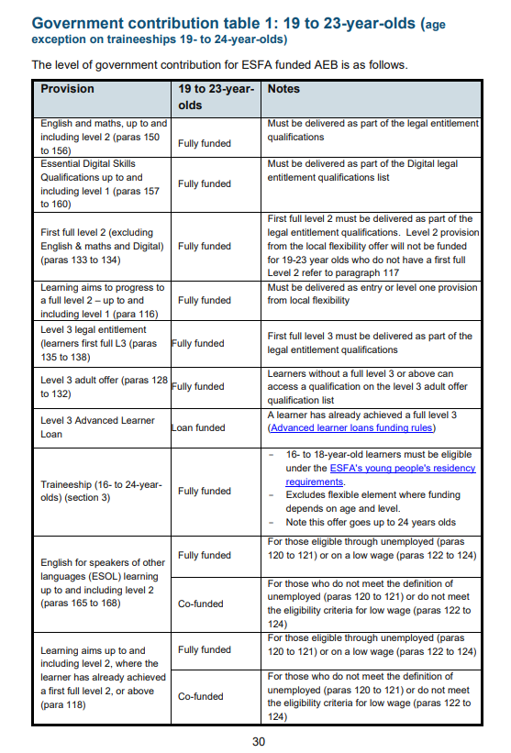

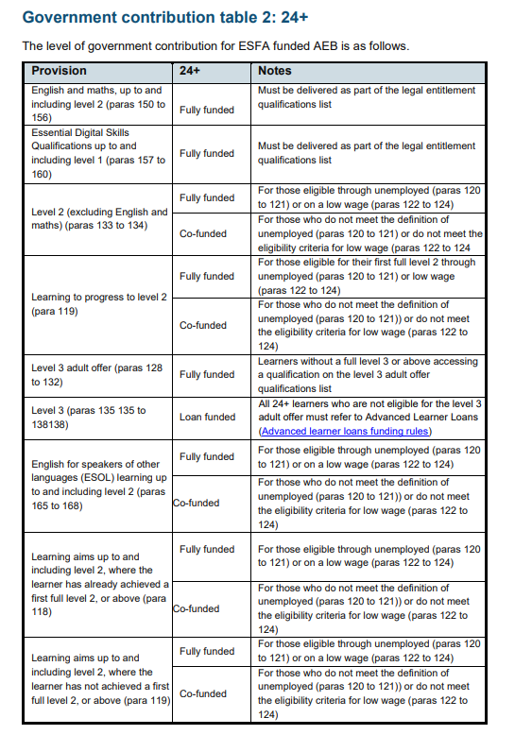

Low wage maximum salary is £17374.50

WMCA Adult Funding Matrix

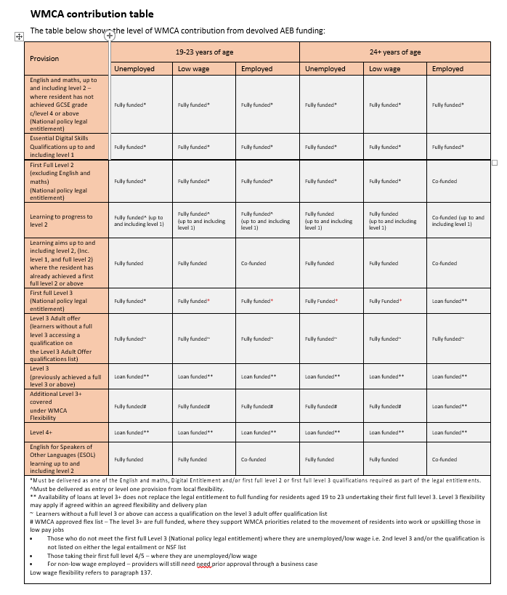

Low wage maximum salary is £18135, note for ESFA is a lower amount