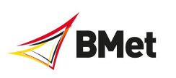

From 1st July 2022 you can apply to any of BMet’s range of University-Level courses through Clearing, if you haven’t secured a place at university in the academic year 2022-2023 and you’re not already holding an offer from a college or university, and the course still has places available.

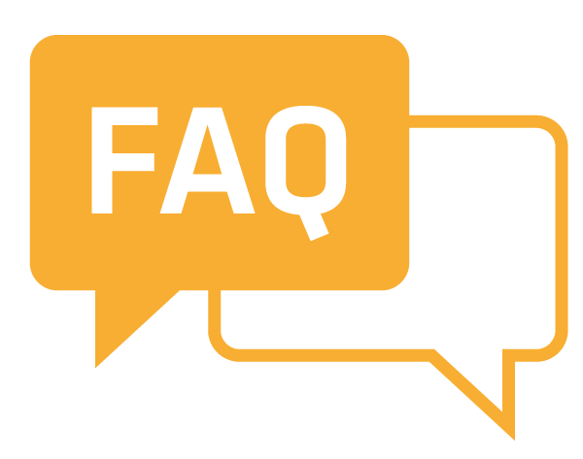

Q What is Clearing?
Clearing is an application service available between July and September that colleges and universities use to match students to remaining vacancies on courses.

Clearing helps:
▪ Applicants who did not secure a place during the main UCAS cycle to find suitable vacancies on higher education courses.
▪ Applicants who received and accepted offers from colleges or universities but did not meet the conditions of their offer.
▪ Applicants that already have their exam results but no offers.
▪ Applicants that have recently decided to study a higher education course. For further information please see UCAS Clearing website.

Q Where can I find Clearing vacancies?
We will publish a list of courses which have places in Clearing at the beginning of July on our website, social media platforms and UCAS website.

Q When do A level results come out?
A Level exam results come out on 18th August 2022. You will usually have to go into your school or college to collect your grades – exact times and details will vary. Before your school opens you can usually log on to UCAS Track to find out whether your status has changed and if you have met your offer, however this won’t give you any details about how many UCAS tariff points you have. If you call our Clearing A F 2 Hotline, you will need to have your grades in order to get an offer for a place. However, you can call us before and we’ll be happy to advise you on your potential options.

Q What happens after you get an offer?
If we can offer you a place, you’ll receive an email telling you what to do next to accept it. You’ll also get some more information with details of the important things you need to do before joining us in September – like online enrolment, accommodation and student finance.

Q What happens if I’m not successful?
If you are not successful on this occasion, don’t worry, you may be offered an alternative course based on your qualifications and information provided on your personal statement. You’ll be notified via email and confirm next steps where necessary. If you would like an email to confirm why we have made this decision, please contact us.

Q Can I apply through Clearing with an offer from another college or university?
Yes, it is possible. If you decide that you do not wish to take up your place at the college or university that you have confirmed, we can only offer you a place if you are released from your original course choice into Clearing so you can seek a place at another institution, or you are eligible for adjustment, you can use the self-release function on your UCAS Track.

Q When Does Clearing at BMet end?
Clearing at BMet usually closes around October or when the courses in Clearing are full.

Q How do I contact an institute regarding Clearing?
Each institution entering Clearing will have a ‘Clearing Hotline’ that you will be able to ring to be considered for an advertised course. You will be able to discuss your qualifications and motivation for studying the course, although this can vary between colleges/universities. Our Clearing Hotline will be published at the beginning of July. If you have any questions in the meantime email he@bmet.ac.uk

