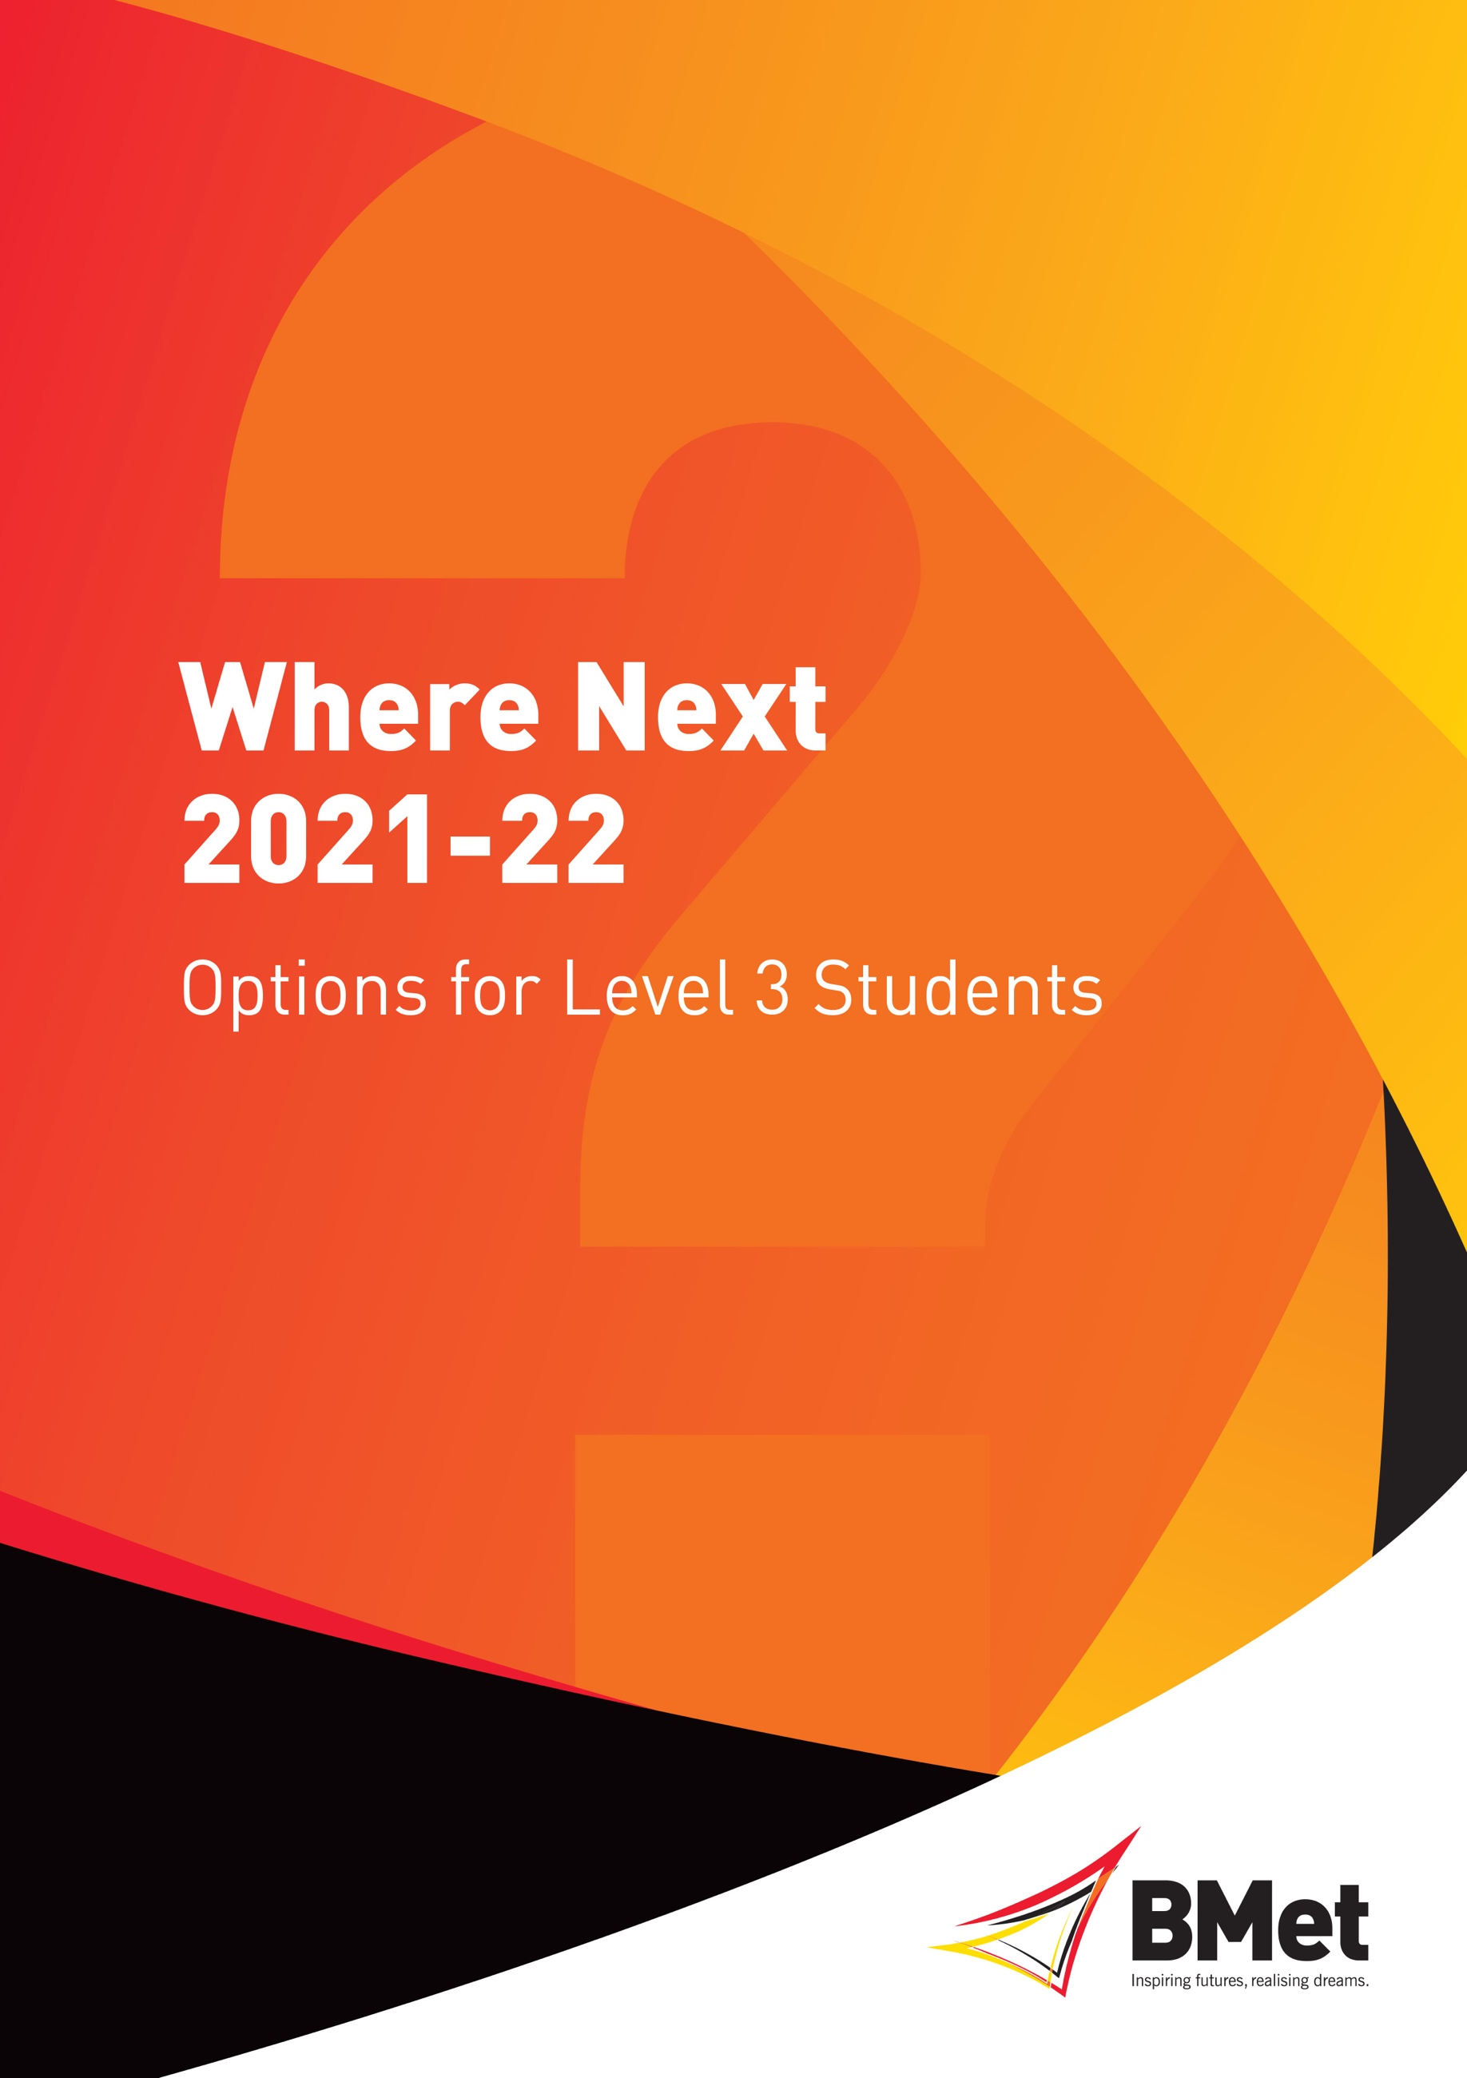

MAKING CHOICES

This booklet has been written to give you information and advice about your options after your current course, and to explain what you need to do to achieve your goals.

There are times when a decision has to be taken which will affect the direction of your life, deciding what to do after college is one such decision. If you plan to go to university, a careful, informed choice will lay the foundations of your career, setting in place the knowledge and skills that you need for future success and giving you a great experience in the process. Overall, people with university degrees are better paid and have higher level jobs than those without. If you fail to do the necessary consideration and planning, a poor decision could lead to you dropping out of your course in debt. Advice and guidance on how to choose a course and apply to university, forms the first part of Where Next?

A Step-by-Step Guide to Applying to University Pages 2-9
UCAS Points Tariff Pages 10-13
College application process and deadlines Pages 14-18
Guidance for Personal Statements Pages 19-20
A Guide to Higher Education Finance Page 21
A Year Out Page 22
Employment Opportunities Pages 23-24
Careers Team Page 25
UCAS College H.E Destination Map Page 26
Notes for your Research Pages 27

However, not all students will want to go to university. There are some good employment opportunities for people with ‘A’ levels or level 3 vocational qualifications. Just like planning a university application, looking for a good job requires thought and preparation. Pages, 23-24 of this booklet gives you some tips to follow.

Help and Guidance

There are many issues to consider at this time of your life and it can help to talk them through with someone who knows about them. The Careers team is here to help you with this. You can find us in Student Services at all the main campuses.

Applying to University

Doing the Research

Step 1 - Develop your course ideas

Timescale: Start in May/June (first year of your course)

Whatever you decide to study, you need to be enthusiastic enough about it to sustain your interest for three years or more. You could consider:

- Continuing with one of your present subjects
- Combining two or more of your current subjects
- Combining an existing subject with a new one
- Taking a completely new subject or subjects
- Taking a general vocational course linked to a broad occupational area e.g. Business Studies, Art and Design, Engineering, ICT
- Choosing a job related course, e.g. Medicine, Physiotherapy, Social Work, nursing or teaching.

Information about the different kinds of courses available in higher education can be found at
www.ucas.com/search

HOWEVER: you should not apply for a variety of different courses with little relationship to each other, as you will need to write a personal statement justifying your choices. If you apply to, for example, Engineering, English and Animation, you are telling the University Admissions Tutor that you are not wholly committed to their subject, and this will affect your chances of getting offers. If you can’t decide, talk to your tutor, or one of the college Careers Advisers.

Still don’t know what you want to study at Uni? Try the Kudos Careers test.

Your intended career may dictate or influence your choice of course. To generate careers ideas, you can use a computer software program called Kudos.

- Log onto website:- https://kudos.cascaid.co.uk

- If you already have a username and password enter it and click ‘Log in’

- If you are a new user type in the licence code, (our postcode, b742nw). Click ‘Sign up’ and you can then create your own unique username and password

- Once logged on, in My progress click onto ME, and then click onto MyFuture, answer the Likes and Dislikes questions and at the end of the questions there will be a list of career opportunities that maybe of interest to you. You can save this information and then go on to the next section.

Alternatively try Start an on-line careers program that supports students with their future career decisions.

Log onto website:- https://www.startprofile.com/

If you already have a username and password click on login. If you are a new user click on register to set up a username and password. Fill in the required fields and then click on get started.

Step 2 - Start your research

Timescale: June – August (first year of your course)

Once you have generated a list of possible course ideas, you will need to research them in detail. Make a note of the places which offer your chosen course. Note the subjects needed, grades/points required and the length of the course. You should also:

- Attend open days at universities you are considering, see university websites, www.opendays.com and www.ucas.com/open-days

- Organize any work experience that might be necessary - for example, any students that are going to apply for a Primary Teaching, Radiography, Physiotherapy, Social Worker, Nursing and Midwifery degrees must have recent, relevant experience. A Careers Adviser can give you guidance on whether this is necessary or desirable for what you want to do.

- Check whether you need to sit an additional admissions test; for example for Medicine or Dentistry, look at www.ukcat.ac.uk , and for Law look at www.lnat.ac.uk. https://www.ucas.com/undergraduate/applying-university/admissions-tests also has details of all admissions tests.

Online Information

You will find lots of useful information on-line. The following sites should help with your research:

- www.ucas.com UCAS is the Universities and Colleges Admissions Service. This website provides information on all courses recruiting through UCAS. An interactive course search will help you find suitable courses and institutions (check out the entry profiles for entry requirements, etc) and it also links to more than 200 university and college websites.

- Check out the websites of individual universities and colleges. Many provide their prospectus on-line, facts and figures about the institution, the opportunity to e-mail admissions tutors and destination statistics of graduates. Some will also give departmental links, giving you access to lecture notes, reading lists, details of lecturers and previous exam papers. Some local examples are:

www.aston.ac.uk/ (Aston University)
www.bmet.ac.uk/ (Birmingham Metropolitan)
www.bham.ac.uk/ (University of Birmingham)
www.bcu.ac.uk/ (Birmingham City University)
www.coventry.ac.uk/ (Coventry University)
www.derby.ac.uk University of Derby
www.dmu.ac.uk De Montfort University
www.newman.ac.uk/ (Newman University)
www.wlv.ac.uk/ (University of Wolverhampton)
www.staffs.ac.uk/ (Staffordshire University)
www.warwick.ac.uk/ (University of Warwick)
www.worc.ac.uk/ (University of Worcester)
https://www.ucb.ac.uk/ (University College Birmingham)

- www.prospects.ac.uk - The Higher Education Careers Services Unit (HECSU) provides information on what you can do with your degree or HND (by subject area).

- https://www.officeforstudents.org.uk/advice-and-guidance/student-information-and-data/discover-uni-and-unistats/ – Here, your can find and compare information regarding the quality of teaching in universities and colleges, including feedback from students combined with official statistics on entry requirements, teaching quality, student results and employment outcomes.
- https://www.push.co.uk/uni-life.html - This site about student life is based on information and opinions of students and recent graduates.

- https://www.nidirect.gov.uk/information-and-services/people-disabilities/learning-and-education - Government Services website providing information and advice about applying to higher education for students with disabilities.

- www.theguardian.com/education/universityguide – See ‘University Guide’ for university league tables.

- www.thestudentroom.co.uk - Where GCSE, A Level and university students share academic and social knowledge: from study help, to choosing a university, careers, and student life.

- www.universitytasterdays.com – provides details of taster day events and open days at universities.

Paper Resources

Copies of these are can be found in the Careers Section of your campus library.

- Choosing Your Degree Course and University by Brian Heap includes degree subjects available and universities that offer them including a description of what the degree entails.

- University Degree Course Offers by Brian Heap includes tables which outline the UCAS Tariff points needed for particular courses; advice about what to include in your personal statement; typical interview questions and special features of courses.

- Prospectuses: - University and college prospectuses provide useful information about the institution, including a brief introduction to course content, entry requirements, career prospects and the accommodation available. Bear in mind though, that they are written by the university to encourage you to apply to them. Make sure you check the financial help individual universities are offering, as they are all different. Alternative prospectuses, written by students at the institution, may also be available from the students' union.

- What Do Graduates Do? Published by HECSU. This book enables you to check out, by subject area, the destinations of recent graduates.

WHICH PARTICULAR COURSES?

Details of all courses are available UCAS Search tool, www.ucas.com/search . There can be huge differences between the same course subjects at different universities. Here are some points to consider:

- Course content and structure can vary a great deal. In English, for example, you might be concentrating on either ancient or modern literature. You might have a set curriculum you have to follow, or some compulsory units and some optional.
- Assessment methods. One course might be assessed totally by exams; another might have a big coursework component.
- Sandwich degrees. For some ‘vocational’ courses like business and engineering, you have a year of paid work experience as part of your degree, which often improves your employment prospects after your degree.
- Professional Exemption: The course might give you exemption from professional exams you might take after your degree e.g. accountancy.
- Professional Recognition: You may need to check that your course is approved by the professional body for that particular field, e.g. by the BPS for Psychology.

You need to consider which universities you would like to go to. Do you want to live at home or go away? If you go away from home, how far do you want to go? A city or campus based university? How highly is the university rated in the quality ratings? What is its rating in the subject you want to study?

And, crucially, what are the entry requirements? The more popular a course or university, the higher qualifications you will need; if you apply for a course that usually requires qualifications above those that your tutors predict you will get, you may well be rejected. Entry requirements are published in university prospectuses and websites, and HE reference books etc. They can be expressed in different ways, as a series of grades per subject; sometimes with particular subjects specified, or as a point score (look out for GCSE and work experience requirements too.) For an explanation of the point’s tariff, see pages 10 - 13.

Access to Birmingham (A2B)

The Access to Birmingham (A2B) scheme is designed to help students from families and communities in the West Midlands who have little or no experience of Higher Education find out about what studying at university involves. To be entitled to the Pathways to Birmingham offer, students must complete the A2B module which is designed to help students make the transition from school to university. The A2B module consists of three elements, a Launch Day to help applicants understand what to do to pass the A2B module. Skills4Uni (an online study support module) to help with academic writing and an assignment specific to the course applied for, set and marked by university tutors, completed after summer exams.
A successful A2B applicant will receive two offers from the University of Birmingham, the standard one and an alternative A2B offer. The A2B offer is typically a reduction of up to two A level grades (e.g. BBB rather than AAB) or 16 UCAS tariff points. The two grade reduction in the offer from the University is not guaranteed for all subjects, but the successful completion of the A2B scheme will be taken into account when A2B offers are made. Application is on-line only via University of Birmingham’s website. For further details on the A2B and how to apply to the scheme go to: http://www.birmingham.ac.uk/undergraduate/advice/a2b/index.aspx

Step 3 - Finalise your course ideas

Timescale: By the end of August (first year of course)

When carrying out your research you need to ensure that your chosen courses and institutions meet your requirements and needs. Use the resources listed earlier to find the information you need.

Remember, for most subjects, you can apply for FIVE courses on your UCAS form. The exceptions are as follows:

Medicine, Dentistry, Veterinary Medicine/Science: FOUR CHOICES ONLY.

Carrying out the research in steps 1 to 3 should help you to choose courses to suit you.

Remember to look out for Careers announcements including those for our Higher Education Fairs to be held at all of our main campuses, as well as personal statements support sessions and the University Finance week advertised on MyMet, Facebook and Twitter.

A Special Message for Access Students

This section is here to help you choose full time university level education courses and apply to college or university. It is particularly for students on Access courses, but any adults considering university level courses may find it useful.

Where will your study lead?

You may have chosen your career but if you are undecided you will find excellent on line careers advice specifically for adults at nationalcareersservice.direct.gov.uk.

The Skills Health Check, self-assessment program is an interactive exercise. It can help you check if you are making the right choices go to https://nationalcareersservice.direct.gov.uk/skills-health-check/home . If you want to study a specific subject but you are not sure what career it will lead to, visit, https://www.prospects.ac.uk/careers-advice/what-can-i-do-with-my-degree

You can also talk to your College Careers Adviser or visit a specialist website such as:

- Accountancy, banking and finance
www.insidecareers.co.uk
- Engineering
www.semta.org.uk

- Information Technology
http://www.bcs.org/category/1

- Law
www.lawcareers.net

- Nursing and all health related professions
www.nhscareers.nhs.uk

- Psychology
www.bps.org.uk/careers/

- Science
www.sciencecareerpathways.com

- Sport
www.careers-in-sport.co.uk

- Social Care
www.skillsforcare.org.uk

- Social Work
www.basw.co.uk

- Teaching
https://getintoteaching.education.gov.uk/

Which Course?

Your career choice may determine your choice of degree course. But you need to be aware that courses with the same title may vary greatly in content and methods of teaching. Most degree courses last three years. Foundation Degrees and Higher National Diplomas are for two years but you can “top up” to a full degree with extra study.

You can choose one subject combine two or take a modular course covering a number of subjects. Universities will give you as much information as they can about their courses. They want you to make the right choice. Use all the information they provide including:

University prospectus: free brochures describing all the university courses. Universities will send you copies on request. Every campus careers library will have reference copies.

University websites: more up to date and often more in-depth information. You can search for all university websites using, www.ucas.com and then the course search.

University Open Days: all universities will have open days two or three times a year. They offer a chance to see the university, attend talks about specific courses and talk to admissions staff. Look on their website or visit www.opendays.com.

Entry Requirements

These vary widely and you need to check them carefully. Courses in nursing and other professional health vocations, teaching and social work will ask for relevant experience. You will be at a disadvantage if you cannot talk about it in your personal statement. These courses are training you for a specific job so universities need to be sure that you fully understand the career you are choosing. Contact the university if the entry requirements are not clear. You can search for voluntary work at https://www.ncvo.org.uk/ncvo-volunteering/i-want-to-volunteer

Which University?

Many mature students want to stay close to home and in Birmingham there is a good choice open to you. But no two universities are the same. Some are much more selective than others and this will be reflected in their entry requirements.

Not all of them offer the same subjects; some have particular specialisms; they vary considerably in size. If you intend living away from home, check the accommodation when you visit.

Make sure this is a place where you will want to spend three years. Use https://www.officeforstudents.org.uk/advice-and-guidance/student-information-and-data/discover-uni-and-unistats/ to find out how universities are ranked and rated by their students.

UCAS Tariff Points System for Entry to Higher Education 2022

A Level/Advanced GCE AS Level/Advanced Subsidiary GCE

GRADE | POINTS
A* | 56 |  | GRADE | POINTS
A | 48 |  | A | 20
B | 40 |  | B | 16
C | 32 |  | C | 12
D | 24 |  | D | 10
E | 16 |  | E | 6
*AS points will only count if subject not continued to A2 level.

Pearson BTEC National qualifications replaced the BTEC (QCF) suite of qualifications from September 2016/2017
 | Grade |  |  |  | Tariff Points
New Pearson BTEC Level 3 National Extended Diploma | New Pearson BTEC Level 3 National Diploma | New Pearson BTEC Level 3 National Foundation Diploma | New Pearson BTEC Level 3 National Extended Certificate
D*D*D* |  |  |  |  | 168
D*D*D |  |  |  |  | 160
D*DD |  |  |  |  | 152
DDD |  |  |  |  | 144
DDM |  |  |  |  | 128
DMM | D*D* |  |  |  | 112
 | D*D |  |  |  | 104
MMM | DD |  |  |  | 96
 |  | D* |  |  | 84
MMP | DM |  |  |  | 80
 |  | D |  |  | 70
MPP | MM |  |  |  | 64
 |  |  | D* |  | 56
PPP | MP | M | D |  | 48
 | PP |  | M |  | 32
 |  | P |  |  | 24
 |  |  | P |  | 16

Pearson BTEC (QCF) suite of qualifications known as Nationals

 | Grade |  |  |  | Tariff Points
Pearson BTEC Extended Diploma (QCF) | Pearson BTEC Diploma (QCF) | Pearson BTEC 90-Credit Diploma (QCF) | Pearson BTEC Subsidiary Diploma (QCF)
D*D*D* |  |  |  |  | 168
D*D*D |  |  |  |  | 160
D*DD |  |  |  |  | 152
DDD |  |  |  |  | 144
DDM |  |  |  |  | 128
DMM | D*D* |  |  |  | 112
 | D*D |  |  |  | 104
MMM | DD |  |  |  | 96
 |  | D*D* |  |  | 84
MMP | DM |  |  |  | 80
 |  | D*D |  |  | 78
 |  | DD |  |  | 72
MPP | MM |  |  |  | 64
 |  | DM |  |  | 60
 |  |  | D* |  | 56
PPP | MP | MM | D |  | 48
 |  | MP |  |  | 36
 |  |  | M |  | 32
 |  | PP |  |  | 24
 |  |  | P |  | 16

NCFE CACHE Technical Level 3 Diploma in Childcare and Education (Early Years Educator)
Grade | Tariff points
A* | 168
A | 144
B | 120
C | 96
D | 72
University of the Arts London (UAL) Extended Diploma in Art & Design/Creative Media Production & Technology/Creative Practice, Art, Design and Communication
Grade | Tariff points
D | 168
M | 120
P | 72
University of the Arts (UAL) Diploma in Art & Design/Creative Media Production & Technology/Creative Practice, Art, Design and Communication
Grade | Tariff points
D | 84
M | 60
P | 36
UAL Art & Design Foundation Diploma
D | 112
M | 96
P | 80
UCAS have introduced new Tariff points for courses starting from September 2017, enabling UCAS to include more qualifications.
- The new Tariff points are much lower than the original Tariff points. For example, an A level grade A* equates to 56 points under the new Tariff, whereas before it equated to 140. The value of the A level remains the same, but universities will just use lower tariff numbers in their entry requirements than in previous years. The above tables are not exhaustive in order to check the tariff point score for your qualifications including Access qualifications go to the following link: www.ucas.com/tariff-calculator
- Just because a qualification is on the Tariff, doesn't mean a university will accept it. Therefore, it’s really important to check the entry requirements for the course you’re interested in.
- There are only a certain number of qualifications on the Tariff. A university may accept a qualification even if it isn’t on the Tariff, so it’s best to check with them to see if they will accept your qualification. Remember, not all universities use Tariff points.
UCAS Tariff Calculator:
If the course you’re interested in refers to Tariff points in its entry requirements, you can use the UCAS Tariff calculator at www.ucas.com/tariff-calculator to find out how many points your qualifications and grades are allocated. Not all qualifications are on the Tariff – don’t worry if you can’t find your qualification, as a university may still accept it. Make sure you read the guidance notes on the calculator to ensure you understand how the Tariff works.

How to apply to university through UCAS

Making your Application

From 18th May 2021, once you have chosen the courses you want to apply to, and had your personal statement approved by a member of staff (see below), you can start your online application. 2022 entry applications can be submitted by BMet to UCAS from 7th September 2021

STUDENT GUIDELINES FOR APPLYING TO UCAS – 2022 ENTRY

a) Decide on the courses you would like to apply to (maximum 5).
b) Get your personal statement checked and approved by your tutor.

TO START AN APPLICATION, YOU NEED A UCAS HUB ACCOUNT:
- Go to www.ucas.com, click on Sign in and select student from the drop-down menu.
- Select undergraduate 2022 Entry.
- Choose ‘register’ if you are going in for the first time. Fill in the short form with your contact details and set up a password make sure it is memorable, write it down or save it in your phone. Accept terms and conditions and click on register.
- UCAS will email to you a code to verify your email address. Type in the code and click on verify.
- Once you’ve registered, UCAS will ask you a few questions like when you want to start studying, where you live and what you’re interested in so UCAS can tailor the information you see. Make sure you choose the correct study year, 2022 if you want to start next year. Choose the correct level of study, it's Undergraduate if you are still at school/college.
- Once you have answered all the questions scroll right to the bottom of the page to Create account.
- To start your 2022 UCAS application click on the Your application tile with the red circle.
- It will ask you if you're applying with the help of your school, college or centre then select Yes and enter the College buzzword, 2022progression and confirm the details are correct.
- Once your application has been linked, you can then select a group (your personal tutor) from the drop-down list.
- You can leave and return to your form as many times as you like, and you can do it anywhere with internet access, using your password. HOWEVER, IF YOU ARE LEAVING YOUR FORM FOR ANY LENGTH OF TIME, LOG OUT, OR YOU WILL BE “LOCKED OUT”.
- Then work through the sections. NB always use drop down menus. Mark sections as complete when you are finished.

Most of the information required on the application is straightforward. Please read the following to avoid making errors on your application:

Nationality details

Nationality – If you are a UK citizen, choose UK national. If you were born in the UK but have a different nationality, you will be asked additional questions. The information you provide will help universities and colleges in determining your eligibility and allow them to assist you with the visa application process, if required.

Choices;

Enter between 1 and 5 university course choices (Maximum 4 choices only for Medicine, Vet and Dentistry and only one choice of Oxford or Cambridge not both).

Note: you will only be asked to declare any relevant criminal convictions if you apply for certain courses, for example those that involve work with children and vulnerable adults, such as medicine, teaching, or social work. Please read the information provided to avoid ticking the box in error.

Each university will only be able to see your applications to their courses. If you apply to several courses at the same university they will be able to see all these. Choices are not sent in preference order. UCAS send an application to all the universities at the same time and they don’t know where else you have applied.

Education

Start by clicking Add place of education. Type the name of your secondary school and college. Once you find your centre, click on the name and the Exam centre number will automatically populate. If an exam centre number doesn’t appear that’s ok, type in the appropriate exam centre number for the college at which you are studying. Exam centre numbers are 20313 for Sutton Coldfield College, 20051 for James Watt College and 20183 for Matthew Boulton College. Add when you started and finished, and if you’re a current student add August as the end date.

Enter all your qualifications regardless of grade achieved, and what you are doing now with completion, not start dates.
- A level is GCE Advanced level. AS level is GCE Advanced Subsidiary level. Adding unit grades for AS subjects is optional. There is no need to put in an AS result where you have completed the A level.
“Access” is “Access to HE Diploma”
- BTEC students will need to enter a BTEC registration number which your tutor can supply you with.
- 2022 examinations, mark results as “pending”.

Employment

Not everyone will have something to enter here. It's up to you whether you create an employment record here or not, for employer name, put the name of the company - but remember to mark the section as complete!

Pay and Submit

There are 4 steps to the submission process. As you complete the fields, mark each section as completed. When you have finished, check that there are no error messages. These are highlighted in colour. At the bottom of the application, click Accept and proceed (or return to application if you want to make more changes). Update your preferences. You must tick the box at the bottom of the page to confirm you have read and understood the terms and conditions. Then click Accept and proceed, or you can Return to application, or Return to marketing preferences.

To pay and submit click pay now. Then pay by credit/debit card (you can use someone else’s with permission) - £22 if you have applied to only one course at one university, £26.50 for 2-5 choices. (Fees correct as at April 2021)

Next…..

Your application will then be checked through by your tutor and will be returned to you if there are errors. If there are no errors, it will be approved, and the reference added, ready for your application to be sent to UCAS.

The college sets deadlines for you to complete your application:

- For applicants to Oxford, Cambridge, Medicine, Dentistry and Vet. Science:
Friday 1st October 2021.

  - College target date for all other 16-19 applications:
Friday 22nd October 2021.

  - College deadline for all adult Access applications:
Friday 12th November 2021.

After this date we are unable to guarantee that your application will reach UCAS by the deadline for your chosen course.

If you meet your deadline, the college has time to check your application, write your reference and send the application to UCAS by their deadlines: 15th October for Oxford, Cambridge, Medicine, Dentistry and Veterinary Science, and 15th January for all other institutions/courses. The earlier it is sent, the better; universities make decisions as soon as they receive applications, and popular courses may fill up early. Miss the college deadline, and you may miss the UCAS deadline, and not be considered at all by some institutions.

Applicants to practise-based music courses at UK Conservatories apply through UCAS Conservatories. Further details on the conservatoire application process and how to apply are available at: https://www.ucas.com/conservatoires/how-apply-through-ucas-conservatoires.

After you have applied

Head to your UCAS Hub to track your application. Click your application to: see your choices and personal information, view and reply to your offers. You may also receive letters directly from the individual universities.

UCAS forward your application to your chosen universities. The universities then either offer you a place (telling you what you need to achieve), decline you (usually if you have applied unrealistically or to a very high demand university/subject), or invite you for interview. Universities which are offering you a place will ask you to attend a special Open day just for that course. Go, if you possibly can.

Interviews: Usually you will be interviewed if you are applying for Oxford or Cambridge or for medicine, veterinary science, nursing, or other health related courses, teaching or social work at any university. The Careers team can provide help and advice regarding interview preparation for Academic interviews.

When all the universities have replied, in your UCAS Hub you should select a Firm (first) choice and may select an insurance choice as well (a lower offer which you would take if you do not get your firm choice). All other outstanding offers must then be declined.

If you do not receive any offers, you will be able to make a supplementary application from the end of February until early July. This is called UCAS Extra and you apply for one course at a time through UCAS Hub. For more information go to www.ucas.com/extra

Be available when your results come out. If you get what you need for your firm choice, you have that place. If you just miss, you should check to see if they have accepted you anyway. If not, if you have the grades for your second choice, then you have that place. If you’ve done better than you needed to, you may be able to apply for a different course. If you do not have a place, you will be eligible to apply for a course through Clearing, for any course that has vacancies. Staff will be available during this period to advise you about the process.

Adjustment - If you've met and exceeded the conditions of your conditional firm offer, you may be able to use Adjustment to find an alternative course. Adjustment is a chance for you to reconsider where and what to study. If you've had a firm conditional choice accepted – and therefore made into an unconditional firm choice – you could potentially swap your place for one on another course you prefer. Adjustment is available in August 2021 (dates tbc). It's entirely optional, and a lot of competitive courses will be full – but other applicants might have missed their conditions or swapped a course too, so it could be worth seeing what's available.

GUIDANCE FOR PERSONAL STATEMENTS

Your personal statement is your opportunity to ‘sell yourself’ to the universities/colleges that you are applying to. It can make the difference between being offered a place on a course, and being rejected, so it must be as good as possible. It should be around 47 lines in length or 4000 characters, including spaces. Do not use borders, headers or footers.

Extra reading/research around your chosen degree subject is recommended to boost successful personal statements especially for competitive courses. www.studential.com and https://www.thestudentroom.co.uk provides examples of personal statements in degree choices and information regarding academic interview preparation.

The UCAS personal statement worksheet can be very useful if you are having difficulty in getting started – www.ucas.com/personalstatementskills

Your statement could include a paragraph on each of the following:

Opening paragraph:

- Explain why you are applying for the particular HE courses you have chosen. This could include:-

- A keen interest in the subject (give details and examples) and what sparked your interest.
- Career aims and reasons for them.
- Suitable skills and abilities (the course you are applying for will have an entry profile on the UCAS website via the search facility, telling you what kinds of personal skills and qualities are required).
- If you’re applying for slightly different subjects, try to identify common factors.

A paragraph(s) regarding your current courses should include the following:

- Pick out any areas from your current course that you have enjoyed and talk about any skills that you have developed e.g. communication, technical skills, research, analysis, presentations, organisation, problem solving, working in a team, leadership - giving examples and saying why they are relevant to the course you are applying for.

- If it is a vocational course (linked to a particular kind of work), write about any work experience you have undertaken and the skills you have gained. Work experience is an essential entry requirement for some courses such as Social Work, Teaching and Health related courses.

A paragraph(s) to show that you have skills suited to university life and will benefit from it. This could include:

- Details of any part-time jobs or work experience (voluntary or paid) not already mentioned, and useful skills/experience gained, e.g. team working and communication skills.

- Information on outside hobbies and interests e.g. social, leisure, music, travel, sports, Duke of Edinburgh scheme participation, music etc, and details of any positions of responsibility held, family responsibilities and any other qualifications you may have (e.g. for music). Try to avoid ‘socialising with friends’ as this is something most people do. Instead think about what makes you interesting and different from other people.
- If deferring entry, give reasons why and provide information on how you plan to use your time during your ‘gap’ year.

Your concluding paragraph could cover:

- Career aspirations and why your chosen course is relevant to this choice. This demonstrates that you have given thought to your future.

- You could mention how much you are looking forward to the opportunities available to you at university.

Important points to note:

DO NOT:

- Restate information already on the application form.

- Include statements about yourself without giving examples.

- Provide information more appropriate in a reference provided by your tutor (e.g. about your strengths as a student).

Common mistakes:

- Omission of above points.

- Poor grammar and spelling (do a spell check!).

- Negative comments.

SAVE YOUR PERSONAL STATEMENT IN ‘WORD’ AND THEN PASTE IT INTO YOUR APPLICATION

Please Note that all personal statements received in support of an application are subject to checks for plagiarism by UCAS. Any statements showing a potential level of similarity of 10% or greater will be reviewed by members of the UCAS Similarity Detection Service. Applicants and their chosen universities will be notified that the UCAS Similarity Detection service has identified their personal statement as potentially plagiarised. The decision about what action, if any, to take regarding notified cases will be made by individual admissions tutors.
Look out for special support sessions from local universities to help you with your personal statement, organised by your Careers team throughout the year.
A GUIDE TO HIGHER EDUCATION FINANCE

Universities providing higher education can charge up to £9250 a year for their courses. Colleges and private institutions providing higher education can charge up to £6165 a year for their courses. If you’re studying an accelerated degree course, you could get up to £11,100. Universities charging the maximum have to meet strict criteria to make sure that all eligible students, regardless of background, can access those courses. Please contact the relevant university or college for further information. You won’t have to pay your tuition fees upfront.

Government loans are available from Student Finance England to cover your tuition fees and help towards your living costs. You don’t pay anything back until you’ve left university or college and your income is over £27,295 per year. *All HE Finance figures are correct as of April 2021.

For more information about the financial support available and to apply for the student finance package go to www.gov.uk/student-finance.

Scholarships/bursaries are available for a variety of reasons, at different universities; for further details go to https://www.ucas.com/finance/additional-funding or individual university websites.
Some companies will give sponsorships to students while they are at university, most often for courses in engineering, I.T or business; you will usually work for them during university holidays, and sometimes after you have completed your degree. Start to look into it during the summer term of your first year. Further details from www.scholarship-search.org.uk

If you are studying for a degree in Social Work, you may be entitled to receive a non-repayable bursary only available from your second year of study. For further information see http://www.nhsbsa.nhs.uk/Students/4860.aspx

Students studying Nursing, Midwifery and the Allied Health subjects as a second degree can apply for a student loan.
NHS Learning Support Fund – additional funding support available to healthcare students
This includes:
- a training grant of £5,000 per year (for new and continuing students)
- parental support payment of £2,000 per student per year to help with childcare costs
- additional payments for students in specialisms or regions struggling to recruit
- help towards additional travel and accommodation costs to clinical placements over your normal daily travel costs
- an exceptional hardship fund of up to £3,000 per student per academic year
For further information visit: https://www.nhsbsa.nhs.uk/nhs-learning-support-fund

A YEAR OUT

Many students choose to delay their entry into higher education, opting to take out a year to do paid or voluntary work in the UK or overseas. There are a lot of exciting opportunities open to ‘gap year’ students. Most higher education courses accept – or indeed welcome – deferred entry as long as you convince them that you will spend the year productively. The advantages include having new experiences, travelling, becoming more independent, thinking further about your plans, gaining work experience, having a break from study and earning money. On the other hand, certain skills, for example related to Maths or Science, can become rusty.

Your options include paid work. You could perhaps continue with a part-time job, or, more ambitiously, go for a special gap year programme. For example, the ‘Year in Industry’ scheme - https://www.etrust.org.uk/the-year-in-industry - organises high level industrial placements with support and training, and there are agencies which organise au pairing work in America and Canada. You could try voluntary work, at home, for instance doing some kind of social work, or abroad, for example teaching English, or doing archaeological or environmental work. With voluntary work, expenses and ‘pocket money’ are usually paid. Again, you do not always have to find this work yourself, you can apply to agencies that exist for this purpose. Sometimes if you want to work abroad, you will have to raise some money to pay for your air fare. Voluntary opportunities are available from exhibitors at our Volunteer Fairs held annually, look out for details advertising these events on MyMet, Twitter and Facebook.

To find out more:

See websites such as:

- www.campamerica.co.uk
- https://www.campleaders.com/gb/
- www.cityyear.org.uk
- www.bunac.org/
- www.yearoutgroup.org
- https://www.ncvo.org.uk/ncvo-volunteering/i-want-to-volunteer
- www.timebank.org.uk
- www.gapforce.org
- www.raleighinternational.org/

If you know that you want to take a year out when you do your UCAS application, you can indicate this on the application form, or leave your application until the following year (if you do this, bear in mind that you will need to apply in the Autumn). If you decide after you have applied, you can ask your first choice, university to defer your entry.

EMPLOYMENT OPPORTUNITIES

This page informs you about the kind of employment opportunities available to Advanced level students and on how to gain access to these.

What opportunities are available?

As an Advanced level student, you should be looking to build upon the qualifications you will have gained at college. Many employment opportunities aimed at Advanced level students and those with GCSEs at A-C/4-9, will offer you the chance to gain work-based qualifications which will help you progress in your career. For example, some companies run their own management training schemes which qualify you to manage in their own organisations. Others will offer you the choice to do Higher National Diplomas or Certificates (HNDs or HNCs,) Foundation Degrees or other professional qualifications. ‘Apprenticeships’ offer training to Diploma Level 2 and 3, in many kinds of work and some employers now offer higher apprenticeships enabling you to study Foundation degree or degree level qualifications.

Where do I look?

jobs4u is the impartial publicly-funded careers database with regularly updated features on hundreds of jobs, searchable by job families or keywords and offering useful information and links. Go to www.jobs4u.uk.com

notgoingtouni is a website that has information for school and college leavers to help them make informed decisions about their future by showing the opportunities that exist outside of traditional university such as apprenticeships, sponsored degrees, diplomas, gap years, distance learning and jobs go to http://www.notgoingtouni.co.uk
Apprenticeships

If you are interested in starting work and you are keen to learn some skills and gain qualifications, then an Apprenticeship could be the right option for you. On an Apprenticeship you study for qualifications while working and you learn the skills you need for the job you are doing. Apprentices are taken on directly by employers and work alongside other employees. Training takes place while you work, and you’ll also spend some time at a college or work-based learning provider.

Apprenticeships are available across a wide range of different job sectors, including animal care, media, business, construction, health, ICT, travel and Retail. For some job areas an Apprenticeship is one of the main ways to start a career. The most popular job areas to take an Apprenticeship in are Business, Administration and Finance, Hair and Beauty,
Travel and Tourism, Health and Care, Hospitality and Engineering.

For further information regarding Higher and Degree Apprenticeships and to register for apprenticeships you can visit the following places:

https://www.notgoingtouni.co.uk/

https://www.gov.uk/further-education-skills/apprenticeships

For current apprenticeship vacancies through Birmingham Metropolitan view our website, http://www.bmet.ac.uk/courses/apprenticeships, click onto Apprenticeship Vacancies.

Many household names, e.g. Jaguar Land Rover, Tesco, BMW, KPMG and PWC recruit well in advance of college leaving dates, so if you intend to gain employment after your course, you should be looking at their websites to keep up to date with current vacancies. The Evening Mail publishes hundreds of vacancies every Thursday. You can also contact employers directly.

What do I need to do?

- Prepare your CV:
- Fill in application forms carefully
- Get advice on how to approach interviews
- Check websites regularly, e.g. http://www.fish4.co.uk/jobs/west-midlands/all
- www.reed.co.uk and www.monster.co.uk
- Consult Jobcentreplus for local vacancies at your local Jobcentre.

What help can I get?

There are computer programs such as Kudos and Start which can help suggest career ideas. A lot of information is available - ask if you cannot find what you want. See pages 3 and 4 for details on how to login to use Kudos and Start.

Help with all of the above is available from your Careers Adviser see page 25 for contact details.

Who we are and how to contact the Careers team:

Careers Advisor: Katherine Newey
Room SC030
Telephone: 0121 446 4545, ext. 5662
Email: katherine.newey@bmet.ac.uk

Matthew Boulton College
Careers Advisor: Millie Weir
Room MB307
Telephone: 0121 446 4545, ext. 8513
Email: millicent.weir@bmet.ac.uk

James Watt College
Careers Advisor: Dawn Killeen
Room JW152 Blackstone Building
Telephone: 0121 446 4545, ext. 2286
Email: dawn.killeen@bmet.ac.uk

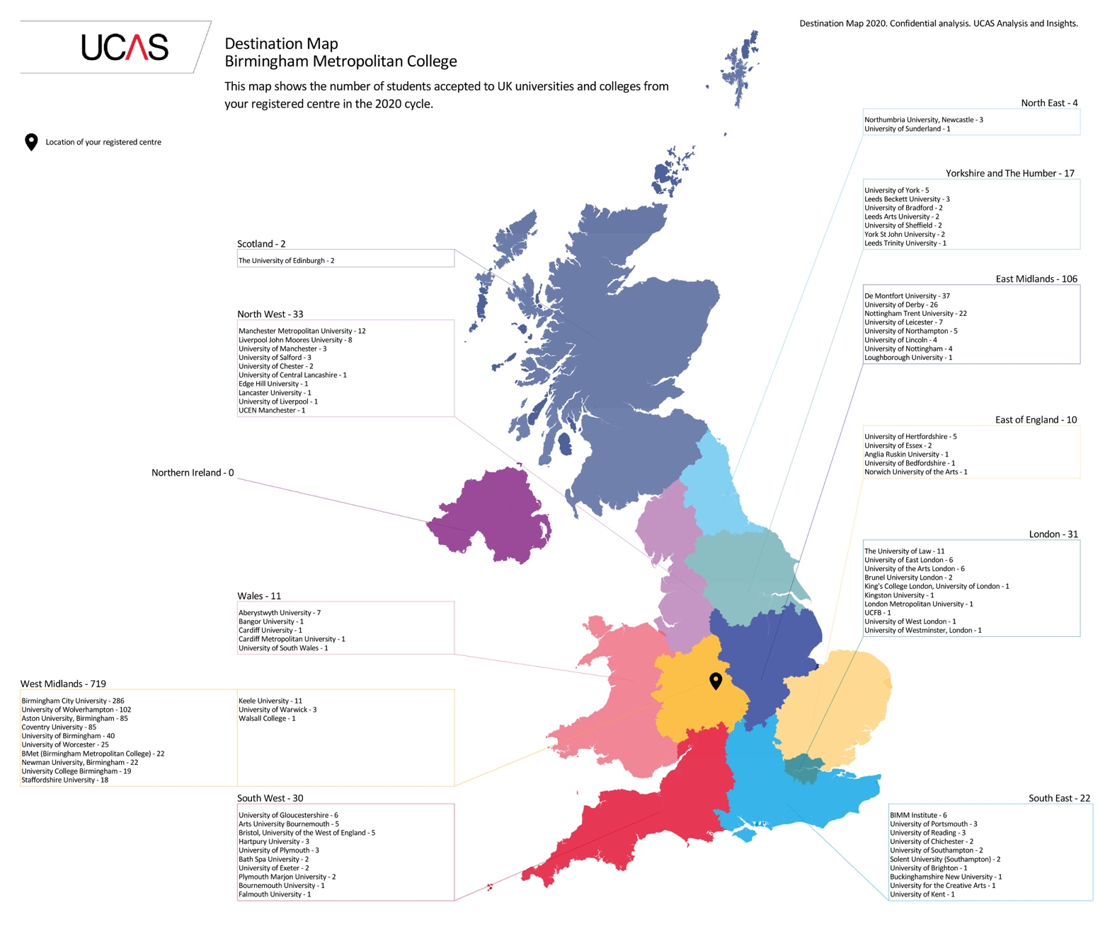

NOTES FOR YOUR RESEARCH



