

**BMET**

**Law Project – Level 3**

**TOPIC:**

**Honour Crime**

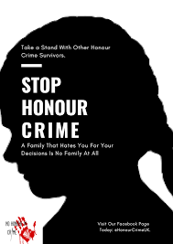 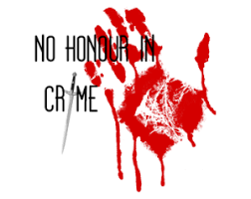

NAME:

**TYPES OF CRIME**

***Starter:***

1. List all of the different crimes that you can think of.

Now put the crimes you have written above into the table below:

|  |  |  |  |
| --- | --- | --- | --- |
| **CRIMES AGAINST THE PERSON** | **CRIMES AGAINST PROPERTY** | **CRIMES AGAINST THE STATE** | **OTHER**  **(PLEASE SPECIFY)** |
|  |  |  |  |

****Task:**

**You have been selected to be on part of the BMET Exclusive debating team. The topic you are debating is honour crime. Your task is to:**

1. **Answer the questions below**
2. **After watching the video – You must come up with a clear argument in favour of or against honour crimes. When giving your answer you must explain why. When explaining your answer consider the following:**

* **Increase or decrease in crime (Statistics)**
* **Sentencing for honour crimes**
* **The defendant**
* **The victim**

**Honour Crime**

Some cultures value family honour very highly, above the rights of individuals in the family. Sometimes this leads to violence or murder.

**Panorama – Britain’s crimes of honour** [**https://www.youtube.com/watch?v=1HPjiYkyh04**](https://www.youtube.com/watch?v=1HPjiYkyh04)

1. What crimes are committed under the blanket of honour crime?
2. What types of behaviour is seen to be ‘dishonourable’?
3. Why are women more likely to be a victim of this crime?
4. What are the current statistics on honour crime?
5. What common features do most ‘honour’ murders have?
6. What happened in the case of Laura Wilson?
7. What were the findings of the opinion polls conducted with the young Asian community?
8. Why is it important to challenge forced marriage?