**Foundation Learning**

**Summer Project**

**Induction Activities**



**Name:………………………………**



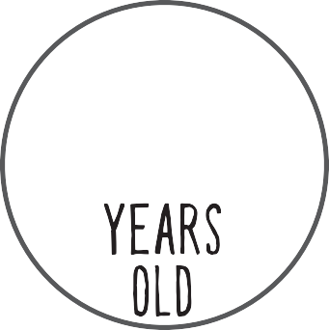



My shoe size is

I AM

I AM

Social Media

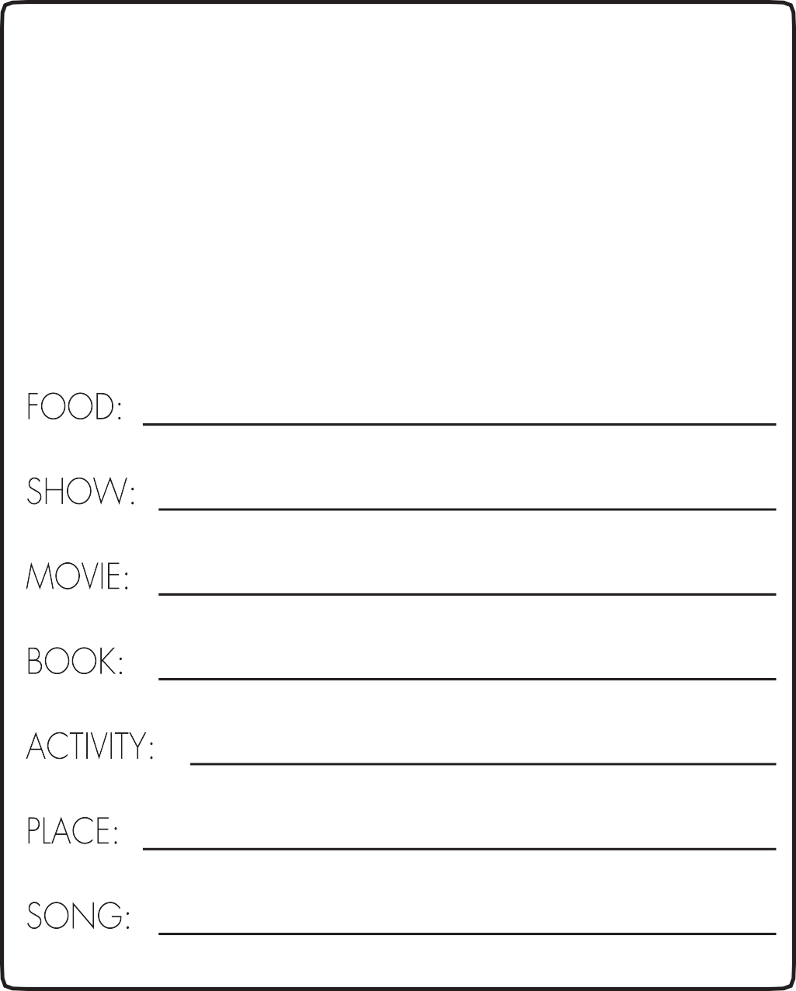

**MY FAVOURITES**



**My Social Skills Rating List**

Need to Work on it OK Average Good Excellent

❶ ❷ ❸ ❹ ❺

Introducing yourself

Introducing others

Joining a group

**1.) Rate yourself on each of the social skills listed.**

**2.) Circle the habits you feel you could improve on.**

Apologising

Aware of your own emotions

Showing concern

**Write a goal about how you could change a social skill you circled that would help you to have a great next term.**

Standing up for

others

Handling the anger of others

Asking a question

Saying thank you

Maintaining friendships

Handling fear

Sharing

Starting a conversation

Avoiding trouble

Responding to peer

pressure

Responding to failure

Being ﬂexible

Dealing with unwanted change

**Personal Coat of Arms**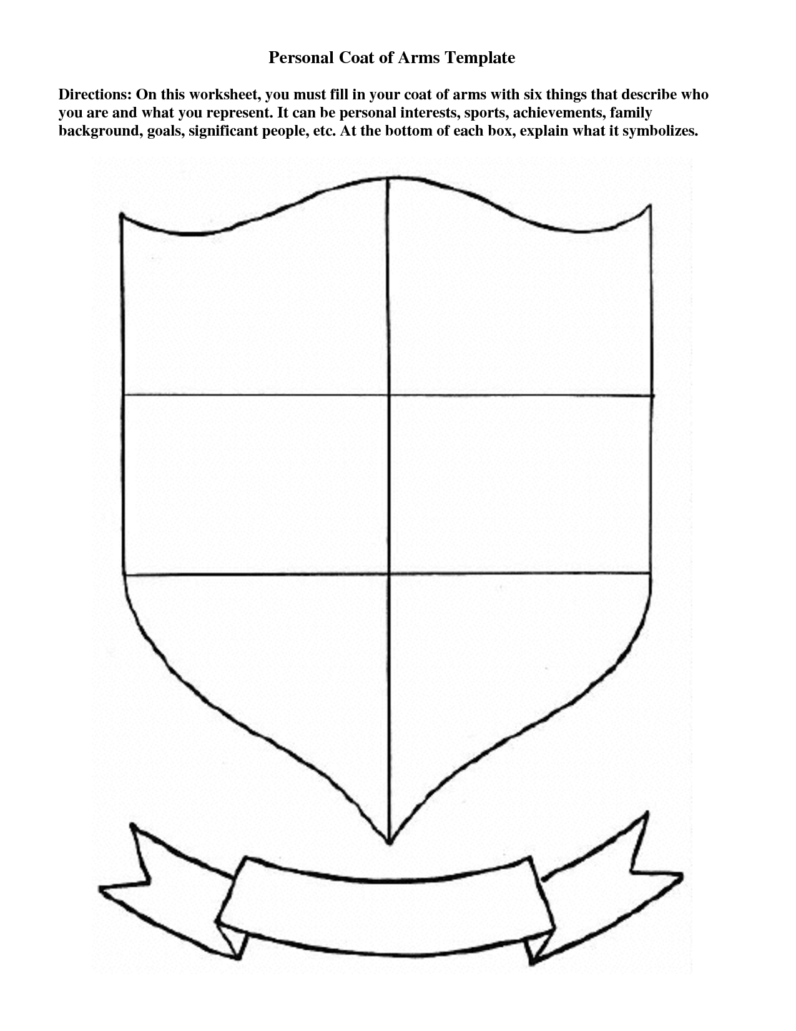

**How I feel about starting college**



What I am looking forward to the most about starting college:

**HOW MY FACE LOOKS**

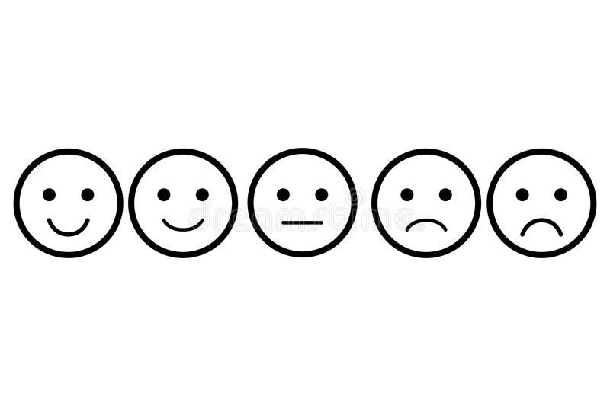

3 Things I would like to know about what college is going to be like:







# My technology set up at home

# Circle or highlight the statement that describes you best.



I have my own computer at home.

I do not have a computer at home.

I have access to a computer at home but I have to share it.

# Laptop

I have my own computer at home.

I do not have a computer at home.

I have access to a computer at home but I have to share it.

I have a smartphone.

I do not have a smartphone.

I have access to someone’s smartphone at home.

# Smart Phone

I have my own tablet at home.

I do not have a tablet at home.

I have access to a tablet at home but I have to share it.

# Tablet

# Camera

I have my own camera at home.

I do not have a camera at home.

I have access to a camera at home but I have to share it.

# Speakers

I have speakers/sound available on my devices (laptop, computer, tablet or smartphone)

I do not have access to speakers/sound on my devices.

I have access to headphones to use sound on my devices.

# Wireless

I have internet access at home.

I do not have internet access at home.

I have limited internet access at home.

# Printer

I have a printer at home.

I do not have a printer at home.

I have access to a shared printer at home

# Cloud Computing

I know how to use cloud-based storage.

I do not know how to use cloud-based storage.

I don’t have access to cloud-based storage as I do not have internet access at home.



Write a letter to yourself with some encouraging words on how you will approach your college year this year. Talk about what you would like to achieve and how you will go about achieving it. You may want to think about the skills you would like to develop in your first year of college and give yourself some tips on how you could do these.

# DEAR,

**LOVE,**

**INTERVIEW SOMEONE YOU ARE WITH**

What 3 words would you use to describe me?








What do you think I will enjoy the most about college?

What time do I need to get up to be on time for college?

**How do you feel about me going to college?**

What are your top three tips to surviving college?

**1.**

**2.**

**3.**

What career do you think I will be good at?



What do you think is the best way for me to get to college and how long do you think it will take me to get there?









Draw a picture showing where you see me in 10 years’ time.

*You can also find and use pictures from the internet if you wish.*

What do you think I need to get better at whilst I’m at college?













**Me now Vs. Future me**

In the space below draw a picture or use pictures from the internet that represent you now and you in the future. This could include pictures that show how you see yourself, how you feel, what you enjoy and dislike, what you hope to have etc.

**Me now**



**Future me**



GETTING A JOB

The job I want...

What I have that will help me get this...

What I need...

GETTING A JOB

What will help me to get this job?

What may prevent me from getting this job?

Thinking ahead



What are you going to take with you when you finish this programme?

IDEAS

What would you like to know by the end of the course?

KNOWLEDGE

What would you like to learn on the course?

SKILLS

What skills would you like to develop on the course?