Welcome to the A Level Centre @ Sutton Coldfield College.
During these uncertain times we wanted to take time to reach out and welcome you to the A Level programme at Sutton Coldfield College.
Although there have been some big changes to the examination and grading processes due to the coronavirus outbreak, we want you to focus on your future, as with everything else in life, these difficult times will pass.
As part of the A Level programme, we pride ourselves on students developing, not just academic but employability and personal/social skills that will help you become fearless in your chosen career.
With this in mind, we have set a small research project for you as part of your transition to college.
A Level Career Research Project
In preparation for starting your A Levels we want you to have thought about the type of career that would interest you.

You will need to complete some research about your chosen career path. This should include which A Level subjects you should choose (list of subjects overleaf), what degree or other qualifications you may need, and what A Level grades you need to reach your intended destination.

You will find below some useful links to help you with your research. You could start by using Kudos/Cascade careers website to look at what careers suit your personality, areas of interest and current skill level.

There are also some Social Action projects that link to different career paths you may want to have a look at. Social Action Projects are designed to get you to apply your knowledge to a current issue in society. Further to this, at the end of Year 1 of A Level you will also take part in a Social Action week.
Transition from GCSE to A Levels

Career Pathway Events
As part of your programme of study you will attend at least one careers event. During these events we have guest speakers, from University lecturers to local, national and international businesses people, talking of their experiences. Although participation is compulsory, they do look great on a CV, job or university application!
Science Technology Engineering & Maths (STEM) | October 2020
Creative & Digital | November 2020
Lifesciences, Social Care, Early Years & Education | January 2021
Business, Professional & Financial | March 2021
Social Science, Public Services & Service Sector | May 2021

In order to maximise your successes, A-Level students have:
- A timetable that runs between 10.00 & 15.45, designed to optimise learning and that is based on research into attention, memory and the teenage brain.
- Weekly subject workshops to support your learning.
- Gaps in timetables are for study, not socialising
- An excellent attendance (>95%) and punctuality
- Part time work that is below 10-12 hours a week
- To ensure that all assessments / homework are completed to the best of their ability
- To ensure that they get enough sleep and look after their health
- To ask for help if they need it – subject or personal tutors are always willing to assist!

A Level Subjects offered @ The A Level Centre.
Biology | Mathematical Studies (core maths)
Business | Maths – A Level
Chemistry | Media Studies
Drama and Theatre Studies | Philosophy
English Language | Physics
English Literature | Politics
Film Studies | Psychology
Fine Art | Religious Education
History | Sociology
Law
Subject offering dependent on applicant numbers, subjects may be withdrawn.

Additional resources for your Careers Research project.
Kudos/Cascade-https://kudos.cascaid.co.uk/#/ explore potential careers based on interest and hobbies. Use the licence code b742nw
Prospects Website - https://www.prospects.ac.uk/careers-advice/what-can-i-do-with-my-degree
UCAS Website - https://digital.ucas.com/search
Russell Group Informed Choices https://www.informedchoices.ac.uk/degrees

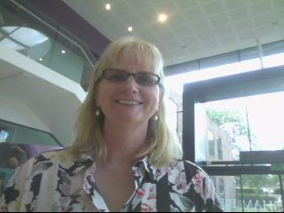
Finally, we wanted you to have some ‘friendly’ faces that you would recognise when you start with us, so here are the managers of the A Level Centre.
Jane Campbell
Director or A Levels
Jane.Campbell@bmet.ac.uk
Ian Moore
Curriculum Manager
Ian.Moore@bmet.ac.uk

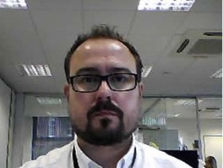
James Mathias
Pastoral/Skills Manager
James.Mathias@bmet.ac.uk;

We look forward to meeting you soon!!
The A Level Team!

