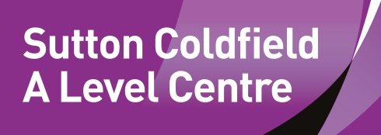
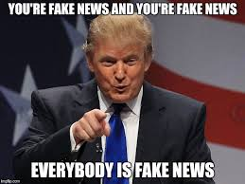
Fake News:
Project

Introduction:
Imagine a world in which we can no longer trust or believe news reports of global conflict, social uprisings, police misconduct, or natural disasters. Imagine a world in which we can no longer believe what our world leaders say in public—or private. Imagine a world in which we simply cannot separate fact from fiction. In this world, how will we function as a democracy, economy, or society?

We are rapidly heading toward a dystopian digital future in which self-organizing online communities will be able to create and disseminate their own world of pseudo-facts and pseudo-reality.

Project Outline:
Look at the five social media posts.
- What is your reaction to them?
- What is their purpose?
- What is the most extreme effect they could have?
- Take one each and research it. One of the posts is true, which one?

Your brief is to create a poster campaign to encourage people of your age group to fact check news stories before sharing/re-posting them.

This should also highlight and explain the 5 key types of fake news that are used in media today.
AI fake Barak Obama.
https://www.youtube.com/watch?v=AmUC4m6w1wo

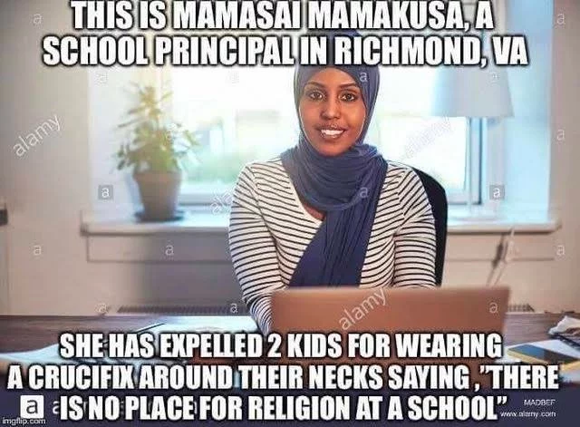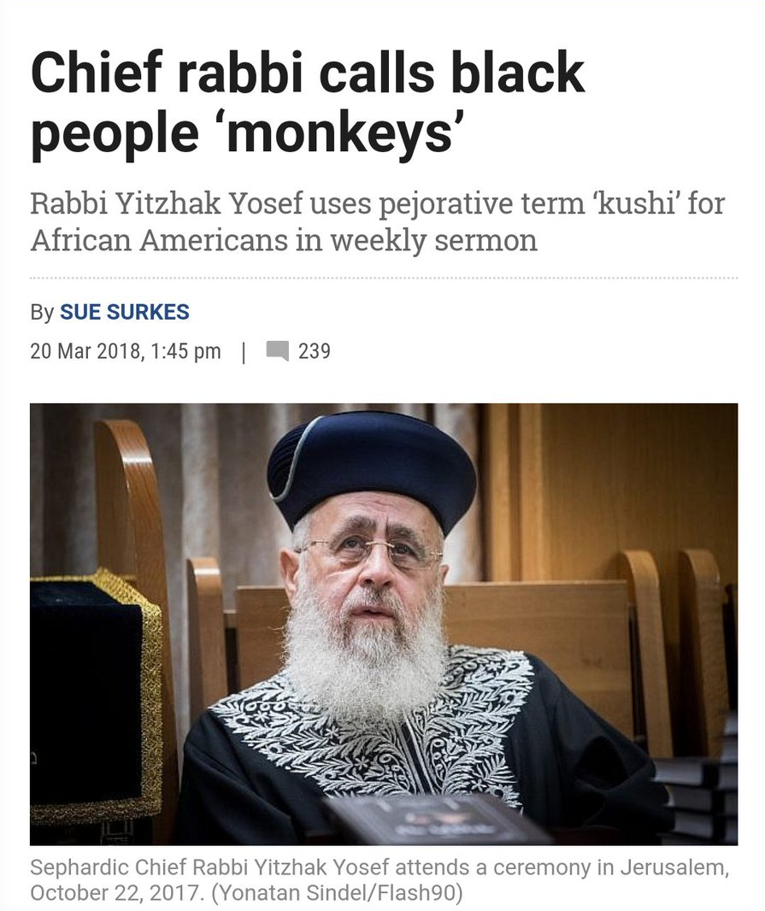

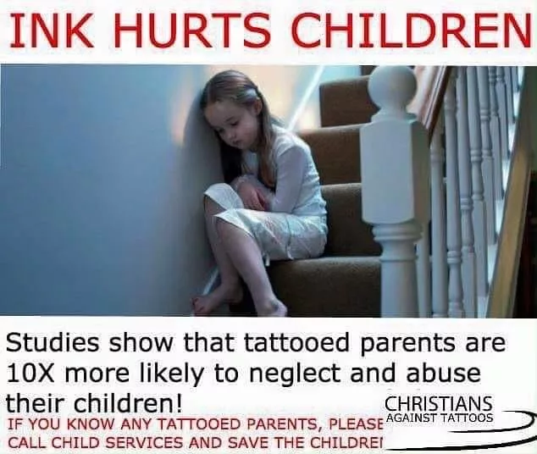

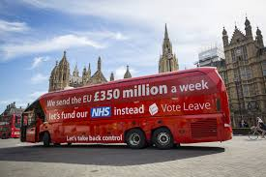
https://www.youtube.com/watch?v=AmUC4m6w1wo

